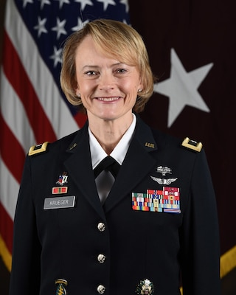
Download

Brigadier General Mary Krueger
BG Mary V. Krueger assumed duties as the Commanding General, Regional Health Command - Atlantic in June 2021.
BG Krueger received her Bachelor of Science degree in Biology from Houghton College in 1991 and was commissioned through the Health Professions scholarship program as a second lieutenant in the United States Army. She received her Doctor of Osteopathic Medicine in 1995 from Philadelphia College of Osteopathic Medicine in Philadelphia, Pennsylvania, and completed residency training in Family Medicine in 1998, and Faculty Development Fellowship in 2002, both at Madigan Army Medical Center, Fort Lewis, Washington. She is board certified in Family Medicine. She received a Master’s in Public Health from the University of Washington in 2002, a Masters of Military Arts and Science from the Command and General Staff College in 2008, and a Masters in National Security and Resource Strategy at the Dwight D. Eisenhower School of National Security and Resource Strategy in 2015.
BG Krueger’s military education includes the War College, Army Command and General Staff College, AMEDD Officer Advanced Course, AMEDD Officer Basic Course, Army Flight Surgeon Course, Division Surgeon Course, and Brigade Command Course. BG Krueger’s military assignments include Supervisory Assistant Deputy Health Affairs, Assistant Secretary of the Army for Manpower and Reserve Affairs, (MPQ), Pentagon, Washington, DC from 2015-2018; Commander, U.S. Army Health Clinic Schofield Barracks, Schofield Barracks, Hawaii from 2012-2014; Division Surgeon, 4th Infantry Division, Fort Carson, Colorado, and Tikrit, Iraq, in support of Operation Iraqi Freedom and Operation New Dawn from 2009-2012; Chief of Soldier Care, Evans Army Community Hospital, Fort Carson, Colorado from 2008-2009; Director of Residency Training, Department of Family Medicine, Fort Bragg, North Carolina from 2005-2007; Associate Program Director, Department of Family Medicine, Fort Bragg, North Carolina from 2002-2005; Deputy Surgeon, Combined Joint Civil Military Operations Task Force, Bagram, Afghanistan in 2003; Director of Research, Family Medicine Residency Program, Dewitt Army Community Hospital, Fort Belvoir, Virginia; Faculty Development Fellow, Madigan Army Medical Center, Fort Lewis, Washington from 2000-2002, and Family Medicine Residency Faculty, Madigan Army Medical Center, Fort Lewis, Washington from 1998-2000, and Commander, Tripler Army Medical Center, Honolulu, Hawaii from 2018-2020. Prior to her current position, she served as the Deputy Chief of Staff for Support, G-1/4/6, Office of The Surgeon General and U.S. Army Medical Command from 2020-2021.
BG Krueger’s military awards include the Bronze Star Medal (Oak Leaf Cluster), Legion of Merit (two Oak Leaf Clusters), Meritorious Service Medal (three Oak Leaf Clusters), Army Commendation Medal (two 2 Oak Leaf Clusters), and the Army Achievement Medal (Oak Leaf Cluster). BG Krueger is an Army Flight Surgeon, has earned the Expert Field Medical Badge, the Army Staff Identification Badge, and holds The Surgeon General’s 9A Designation. BG Krueger is a member of the Order of Military Medical Merit.
BG Krueger is a Fellow of the American Academy of Family Physicians. BG Krueger and her husband Joseph Izaguirre remain grounded through the joy and adventures of parenting their 5 children.

