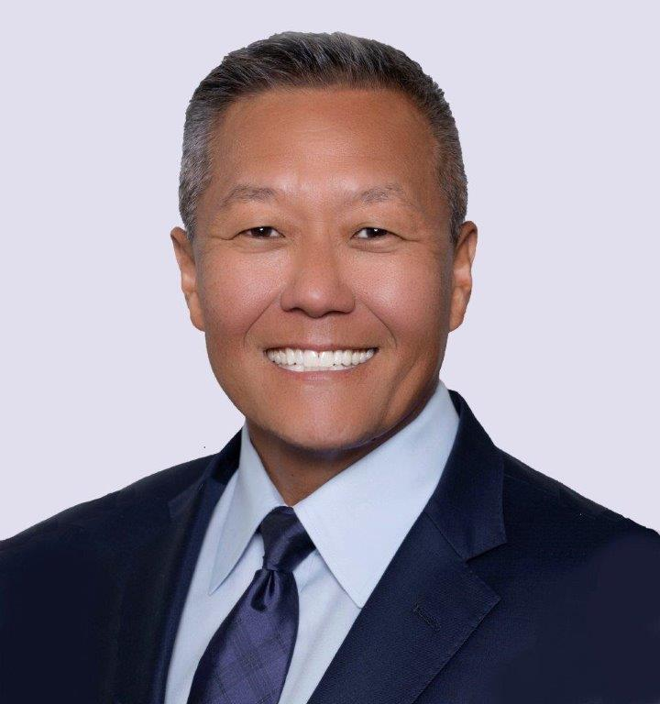
Peter Rhee, MD, MPH, FACS, FCCM, DMCC

Dr. Rhee is the Chief of Trauma and Vice Chair of Surgery at Westchester Medical Center. He is a Tenured Professor of Surgery with New York Medical College and four other universities including the Uniformed Services University of Health Sciences, which is the military medical academy and where he earned his Medical Doctorate in 1987. Dr. Rhee also earned a MPH and a Diploma in the Medical Care of Catastrophes from the Society of Apothecaries of London. He completed his fellowship in Trauma and Critical Care at the University of Washington’s Harborview Medical Center. He is boarded in general surgery and surgical critical care. He is a Fellow of the American College of Surgeons and a Fellow of Critical Care Medicine

Captain Rhee retired from the US Navy after a 24 year distinguished career which included on numerous deployments at sea and with the US Marines. He was the first combat surgeon into Afghanistan with the Marines during Operation Enduring Freedom, two months after 9/11. Upon his return, he founded and developed the US Navy Trauma Training Center at Los Angeles County Trauma Center to train military surgical teams prior to deployment at war. His final deployment was in Iraq during Operation Iraqi Freedom where he served as a combat surgeon at all the Marine Corp bases and was the supporting surgeon for the special operations community in Camp Diamond, which was located in Ramadi. He is a founding member of the US military Tactical Combat Casualty Care Committee (TCCC) which is now a nationally and internationally recognized leader in formulating policies in casualty care. He has served on numerous national steering and trauma research committees including the National Defense Health Board and the Federal Drug Administration’s blood products advisory committee. Some of his numerous honors include being President Clintons’ trauma surgeon during his visits through China, the guest of President Obama as his State Dinner when hosting the President of South Korea and Michelle Obama’s guest during the state of the union address in congress. His research interests has led to numerous novel changes in combat casualty care and especially in the area of blood resuscitation, combat surgery and hemostatic dressings. He is well published with over 390 peer reviewed manuscripts and 26 medical book chapters. He is also the author of 6 books including “Trauma Red: Making of a surgeon in war and America’s cities”.

